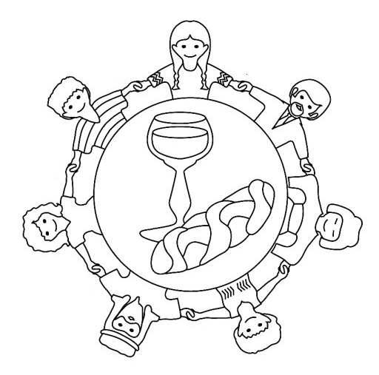

World Communion Sunday

FAITH LOVE TIMOTHY
FEAR PAUL REMEMBER
GOD POWER SELFCONTROL
JOY SPIRIT
We, who are many, are one body
because we share in one bread.

-1 Corinthians 10:17
Children’s Worship Bulletin

Stir Up the Gifts of God

2 Timothy 2:1-7

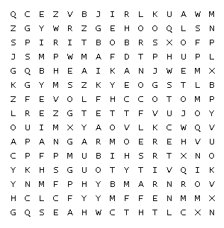

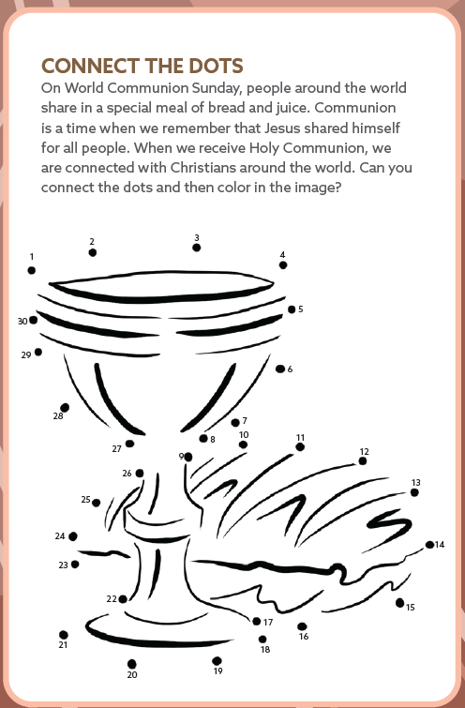

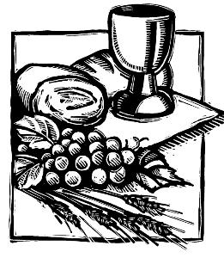
The Lord’s Supper is another name for Communion.

